**Report “Lab 6”**

**Anton Tserakhau**

# Materialized Views- Basic

## Task 01: Create Materialized Views - ON DEMAND

I have created Materialized Views, which will refresh ON DEMAND (based on first Report Layout Monthly).

CREATE MATERIALIZED VIEW mv_sales_city_country_month

BUILD DEFERRED

REFRESH COMPLETE ON DEMAND

AS SELECT restaurant_country_name AS country

, restaurant_city AS city

, TO_CHAR ( amount

, '9,999,999' )

AS amount

, TO_CHAR ( total_price

, '$999,999,999,999' )

AS total_price

FROM ( SELECT DECODE ( GROUPING ( rest.restaurant_country_name ), 1, 'All Countries', rest.restaurant_country_name )

AS restaurant_country_name

, DECODE ( GROUPING ( rest.restaurant_city ), 1, 'All Cities', rest.restaurant_city ) AS restaurant_city

, SUM ( oper.unit_amount ) AS amount

, SUM ( oper.total_price_dol ) AS total_price

FROM u_dw_ext_references.cls_operations oper

LEFT JOIN u_dw_ext_references.cls_restaurants rest

ON oper.restaurant_code = rest.restaurant_code

LEFT JOIN u_dw_ext_references.cls_dishes dish

ON dish.dish_code = oper.dish_code

WHERE TRUNC ( oper.event_dt

, 'MONTH' ) = TO_DATE ( '01-JAN-2012'

, 'DD-MON-YYYY' )

GROUP BY ROLLUP ( rest.restaurant_country_name, rest.restaurant_city )

ORDER BY rest.restaurant_country_name

, rest.restaurant_city);

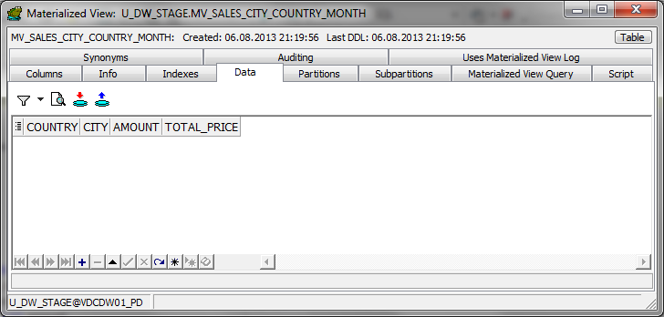

Materialized View is empty; the data will load after script:

EXECUTE DBMS_MVIEW.REFRESH('mv_sales_city_country_month');

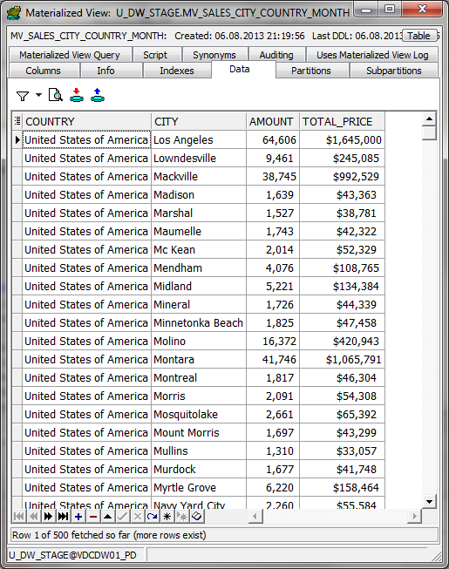

## Create Materialized Views - ON COMMIT

I have created Materialized Views, which will refresh ON COMMIT (based on first Report Layout Daily).

CREATE MATERIALIZED VIEW mv_sales_rest_dish_type_daily

BUILD IMMEDIATE

REFRESH ON COMMIT

ENABLE QUERY REWRITE

AS

SELECT rest.restaurant_name

AS restaurant_name

, rest.restaurant_address

AS restaurant_address

, SUM ( oper.unit_amount ) AS amount

,COUNT ( oper.unit_amount ) AS count_amount

, SUM ( oper.total_price_dol ) AS total_price

, COUNT ( oper.total_price_dol ) AS count_total_price

FROM u_dw_ext_references.cls_operations oper

LEFT JOIN u_dw_ext_references.cls_restaurants rest

ON oper.restaurant_code = rest.restaurant_code

WHERE TRUNC ( oper.event_dt

, 'DD' ) = TO_DATE ( '06-JAN-2012'

, 'DD-MON-YYYY' )

AND rest.restaurant_country_name = 'Germany'

AND rest.restaurant_city = 'Chemnitz'

GROUP BY rest.restaurant_name, rest.restaurant_address;

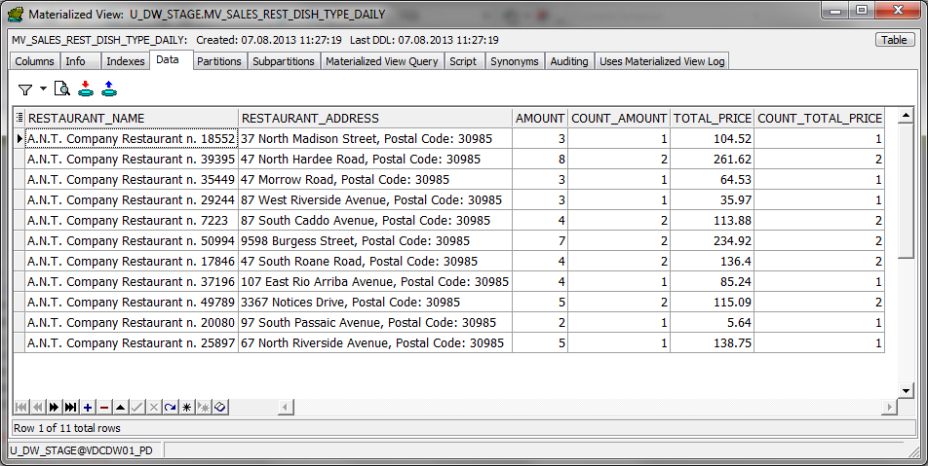

I have run script (set price=price*2 when restaurants in city Chemnitz in Germany):

UPDATE u_dw_ext_references.cls_operations

SET total_price_dol = total_price_dol * 2

WHERE restaurant_code IN (SELECT DISTINCT rest.restaurant_code

FROM u_dw_ext_references.cls_operations oper

LEFT JOIN

u_dw_ext_references.cls_restaurants rest

ON rest.restaurant_code = oper.restaurant_code

WHERE rest.restaurant_country_name = 'Germany'

AND rest.restaurant_city = 'Chemnitz');

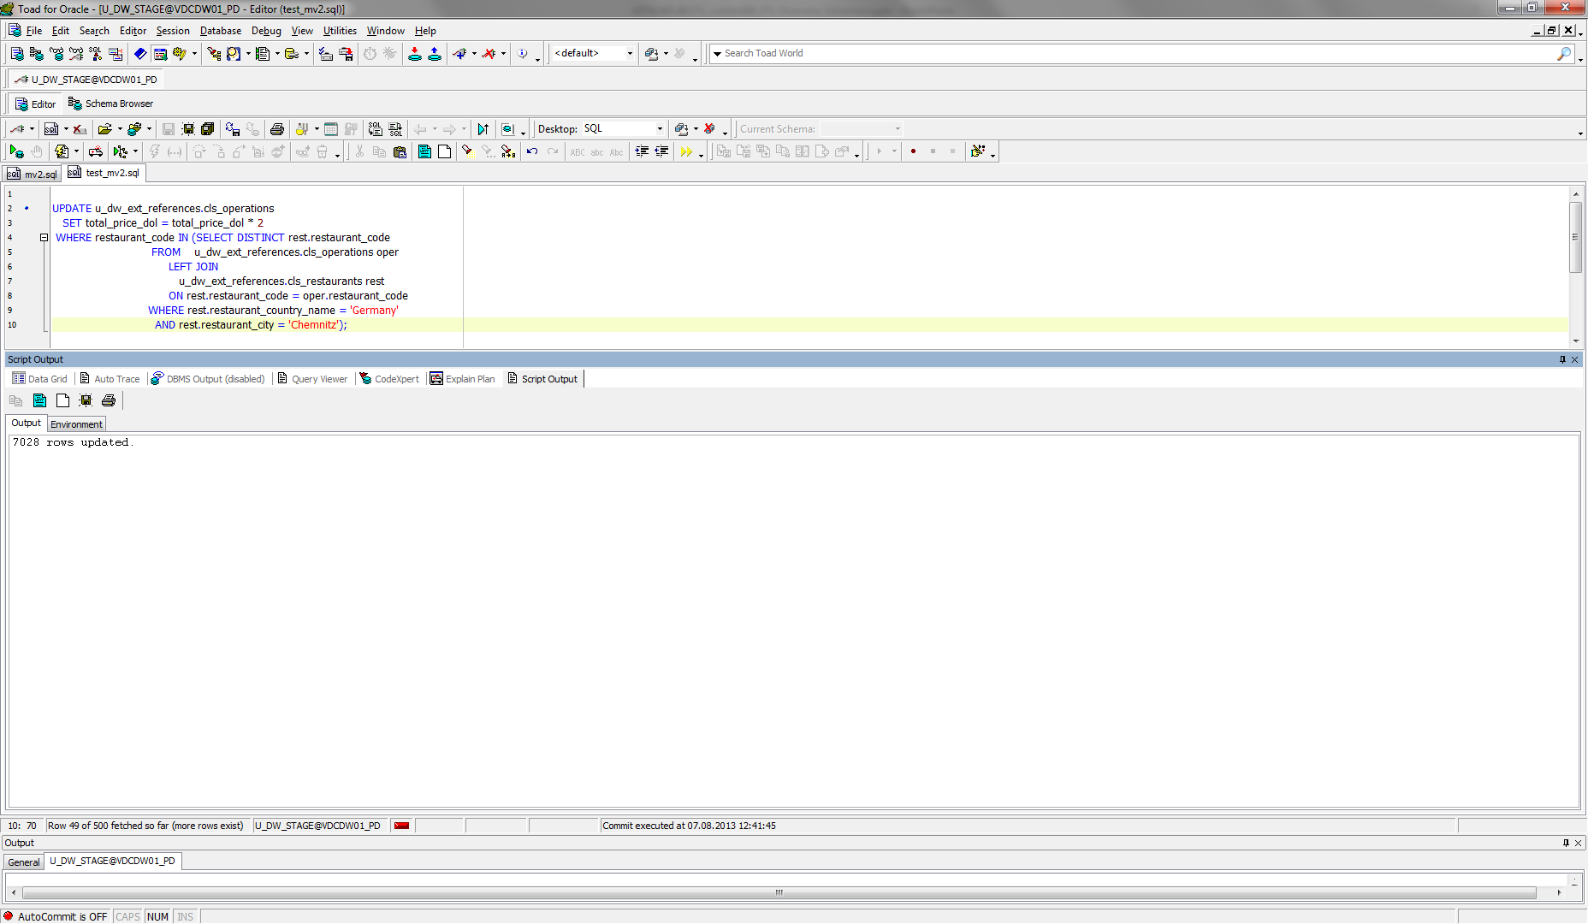

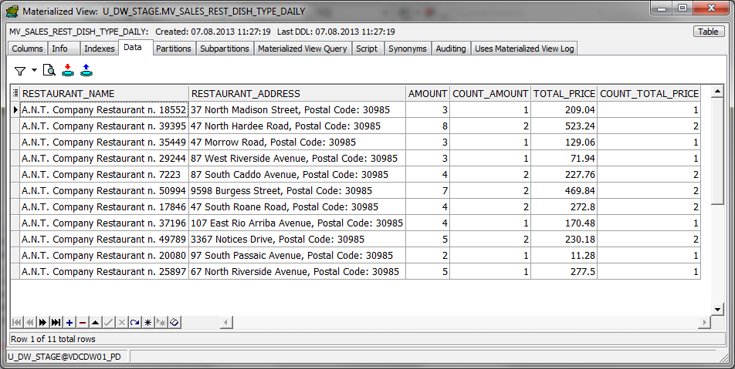

# Materialized Views- Model Clause

## Task 03: Create Materialized Views - Refreshing at definitive Time moment

I have created Materialized Views, which will refresh definitive Time moment (based on last Report Layout Monthly).

CREATE MATERIALIZED VIEW mv_sales_city_cntr_month_delta

BUILD IMMEDIATE

REFRESH FORCE ON DEMAND START WITH SYSDATE NEXT (SYSDATE + 1/1440)

AS

SELECT NVL ( country, 'Total' ) AS country

, NVL ( city, '-' ) AS city

, NVL ( TO_CHAR ( month_numb ), '-' ) AS number_of_month

, NVL ( month_name, '-' ) AS month_name

, TO_CHAR ( amount

, '9,999,999' )

AS amount

, NVL ( TO_CHAR ( delta_amount

, '9,999,999' )

, '-' )

AS delta_amount

, TO_CHAR ( total_sales

, '$999,999,999,999' )

AS total_sales

, NVL ( TO_CHAR ( delta_sales

, '$999,999,999,999' )

, '-' )

AS delta_sales

FROM ( SELECT country_name AS country

, city_name AS city

, month_numb

, month_name

, SUM ( amount ) AS amount

, delta_amount

, SUM ( total_price ) AS total_sales

, delta_sales

FROM (SELECT *

FROM ( SELECT TO_NUMBER ( TO_CHAR ( TRUNC ( oper.event_dt

, 'MONTH' )

, 'mm' ) )

AS month_numb

, TO_CHAR ( TRUNC ( oper.event_dt

, 'MONTH' )

, 'Month' )

AS month_name

, countries.region_desc AS country_name

, cities.city_desc AS city_name

, SUM ( oper.unit_amount ) AS amount

, SUM ( oper.total_price_dol ) AS total_price

FROM t_operations oper

LEFT JOIN t_restaurants rest

ON oper.restaurant_id = rest.restaurant_id

LEFT JOIN t_restaurant_types

ON rest.restaurant_type_id = t_restaurant_types.restaurant_type_id

LEFT JOIN t_dishes dishes

ON dishes.dish_id = oper.dish_id

LEFT JOIN t_dish_types

ON dishes.dish_type_id = t_dish_types.dish_type_id

LEFT JOIN t_dish_cuisines

ON dishes.dish_cuisine_id = t_dish_cuisines.dish_cuisine_id

LEFT JOIN u_dw_references.lc_cities cities

ON rest.restaurant_geo_id = cities.geo_id

LEFT JOIN u_dw_references.t_geo_object_links links

ON links.child_geo_id = cities.geo_id

LEFT JOIN u_dw_references.cu_countries countries

ON links.parent_geo_id = countries.geo_id

WHERE countries.region_desc IN ('United States of America')

AND cities.city_desc IN ('Hardy', 'Woodstock')

GROUP BY TO_NUMBER ( TO_CHAR ( TRUNC ( oper.event_dt

, 'MONTH' )

, 'mm' ) )

, TO_CHAR ( TRUNC ( oper.event_dt

, 'MONTH' )

, 'Month' )

, countries.region_desc

, cities.city_desc

ORDER BY TO_NUMBER ( TO_CHAR ( TRUNC ( oper.event_dt

, 'MONTH' )

, 'mm' ) )

, city_name)

MODEL RETURN UPDATED ROWS

PARTITION BY ( country_name, city_name )

DIMENSION BY ( month_numb )

MEASURES ( month_name, amount, 0 delta_amount, total_price, 0 delta_sales )

RULES AUTOMATIC ORDER

( delta_amount [month_numb] =

amount[CV ( month_numb )]

- NVL ( amount[CV ( month_numb ) - 1], amount[CV ( month_numb )] ),

delta_sales [month_numb] =

total_price[CV ( month_numb )]

- NVL ( total_price[CV ( month_numb ) - 1], total_price[CV ( month_numb )] ) ))

GROUP BY

ROLLUP (country_name, city_name, ( month_numb, month_name, delta_amount, delta_sales ) )

ORDER BY country_name

, city_name

, month_numb);

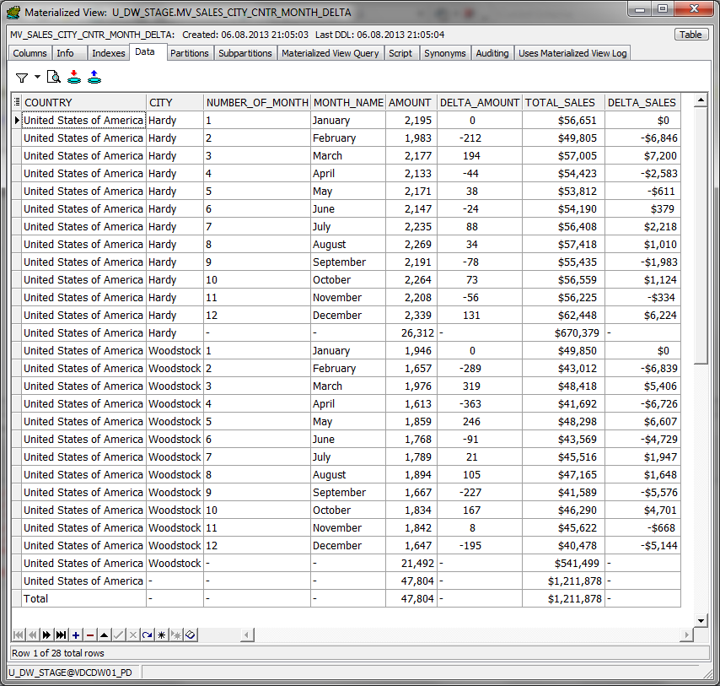

I have run script (set price=price*2 when restaurants in city Hardy):

UPDATE T_OPERATIONS

set total_price_dol=total_price_dol*2

where RESTAURANT_ID in

(Select REST.RESTAURANT_ID

from u_dw_references.lc_cities cities

left join T_RESTAURANTS rest on REST.RESTAURANT_GEO_ID=CITIES.GEO_ID

left join T_OPERATIONS oper on OPER.RESTAURANT_ID=REST.RESTAURANT_ID

where CITY_DESC='Hardy');

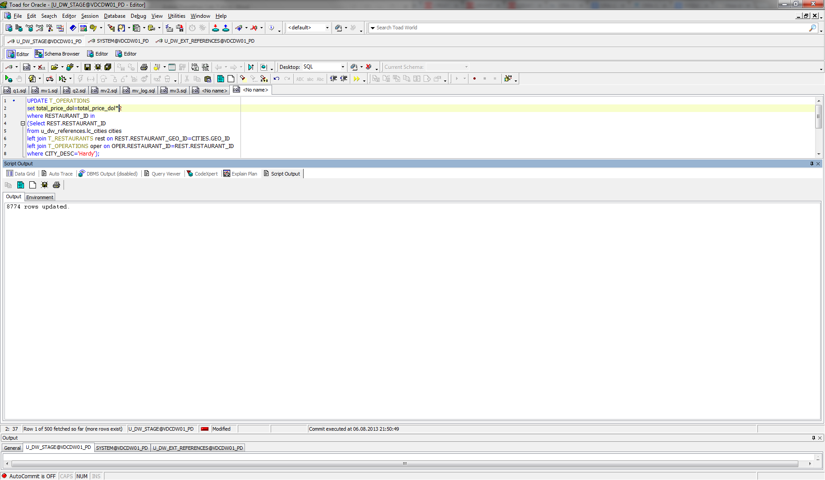

After 1 minute (=SYSDATE + 1/1440):

